Starting Solids Workshop
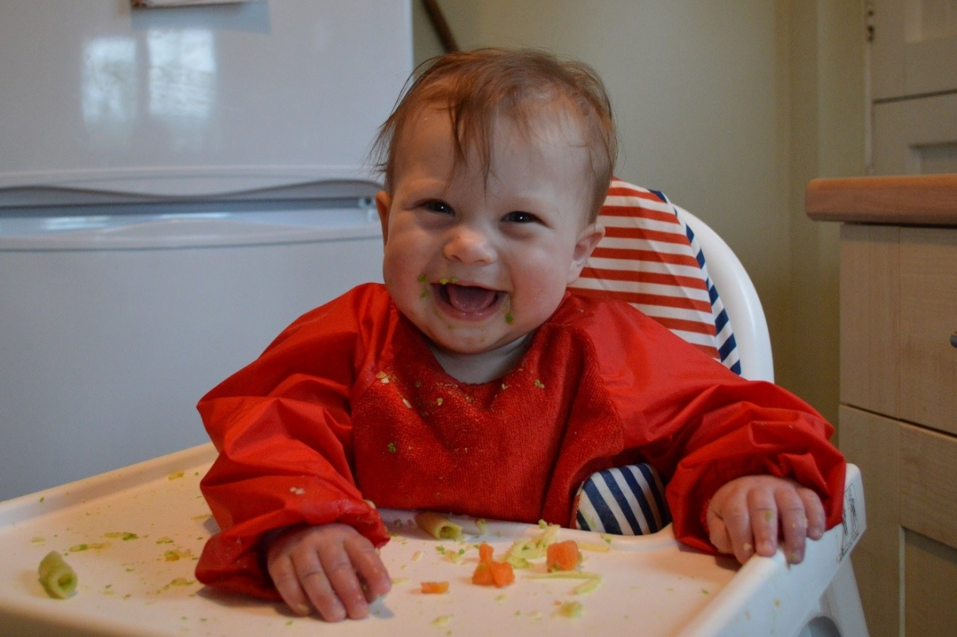
A FREE interactive session for parents/carers and their babies (aged under 6 months)
Starting solids – get some help navigating the confusing world of getting your baby started on solid food
Workshops at the Hackney Playbus
Monday 20th August, 1-3pm, Rowley Gardens, N4 1HH
Wednesday 29th August, 1-3pm, Shoreditch Park, N1 5EF

More information about the Best Start in City & Hackney Service
Instagram: @henryincityandhackney
Email: hcsupport@henry.org.uk
Website: https://henry.org.uk/hackney
Facebook: www.facebook.com/HENRY.HealthyFamilies
Let’s Get Active Workshop
A FREE interactive session for parents/carers and their babies/children 0-5 years old
Let’s get active – join in and learn a whole host of active games and play ideas you can enjoy at home with your baby to support their physical development

Workshops at the Hackney Playbus
Wednesday 22nd August, 10am-12noon, Gilpin Square, E5 0HL

More information about the Best Start in City & Hackney Service
Instagram: @henryincityandhackney
Email: hcsupport@henry.org.uk
Website: https://henry.org.uk/hackney
Facebook: www.facebook.com/HENRY.HealthyFamilies

